**ANAND INSTITUTE OF HIGHER TECHNOLOGY**

**Public Transport Efficiency Analysis IBM Cognos Phase-5**

**PROJECT DOCUMENTATION & SUBMISSION**

**Abstract:**

* Transit agencies are seeking metrics to gauge service quality and allure non-public transport users.
* This study aims to suggest metrics enhancing transit service, with a focus on bus transport's flexibility and popularity in urban areas over rail.The aim of this study is to propose metrics to improve transit service.
* Identifying indicators for transit service quality is crucial for attracting citizens who avoid public transport.
* This research targets proposing effective metrics for optimizing bus transportation services, considering its adaptability and broad urban appeal.
* The study concentrates on enhancing bus transit, recognizing its widespread urban preference and flexibility compared to rail transport .The focus is on bus transportation since it is more flexible compared to rail transportation and widely preferred by the masses in cities.

**Introduction:**

* 1. Exploring public transport efficiency through IBM Cognos leverages its robust analytics capabilities for insightful analysis. Here's a guide on utilizing IBM Cognos for a comprehensive public transport efficiency assessment.
* 2. Data Collection and Integration:
* - Source Variety: Collect data from diverse sources, including ridership, operations, finances, customer feedback, and external factors like weather and traffic.
* - Integration Mastery: Employ IBM Cognos Data Manager for seamless integration, ensuring data cleanliness and consistency for analysis.
* 3. Data Modeling:
* - Model Creation: Leverage IBM Cognos Framework Manager to construct data models, defining relationships, calculations, and business rules for comprehensive analysis.
* 4.Report and Dashboard Construction:
* - Interactive Visuals: Develop dynamic reports using IBM Cognos Report Studio to visualize key indicators like on-time performance, ridership trends, and cost per passenger.
* - Dashboard Dynamics: Utilize IBM Cognos Workspace to create real-time dashboards showcasing public transport metrics, integrating widgets for KPIs, route performance, and customer satisfaction.
* 5.Data Analysis:
* - Ad-Hoc Exploration: Utilize IBM Cognos Analysis Studio for spontaneous data exploration, pattern identification, and on-the-fly insights.
* - Predictive Power: Apply predictive analytics with IBM Cognos Statistics to forecast ridership trends, optimizing routes and schedules for enhanced public transport efficiency.

**2.Methodology**:

* In this study, the focus is on bus transportation,since it is more flexible compared to rail transportation and widely preferred by the masses in cities.
* The primary data source of this study comes from the Department of Transportation for the City of Antalya.
* We load the complete boarding data of December 18,2019 which is a standard weekday.
* The data set formed consist of 305 lines and 608 routes. A route consist of a sequential list of bus stops in either forward or backward (return) directions.
* Each line has opposite two directions except two lines which are omitted in analysis.
* On December 18, 2019, a total of 7347 trips (single direction services) were made and with these trips a total of 381962 passengers were carried.
* However, in this study we slowly focus on the route efficiency.

**2.1 Traversal Route Evaluation:**

* When lines are designed they often start from an origin and return back to where it start.
* Each line may have consider to have 2 routes, a forward and backward route.
* Typically, when trips are completed at the end of the day. the number of passengers at the forward and backward routes are nearly equal.

**2.2 Variance-Area Curves for Route Boarding**

* Simply put, the between-area variance curves are obtained by calculating the variances of gray scale pixel values while varying rectangular unit areas within the 2-D gray scale matrix.
* This 2-D gray scale matrix is constructed from the heatmap image

**2.3 Bus Stop Analysis** :

* Analysis of bus stops can be comprehensive.
* Location of bus stops depends on demand nearby. For the purpose of this study, we do not suggest new bus stops but rather evaluate the boarding demand on existing routes.
* – Bus Stop Id / Name
* – Boarding Count
* – Route Count
* – Service Count
* – Average Boarding Per Route Arrival at Stop
* – Average Boarding Per Bus Service at Stop

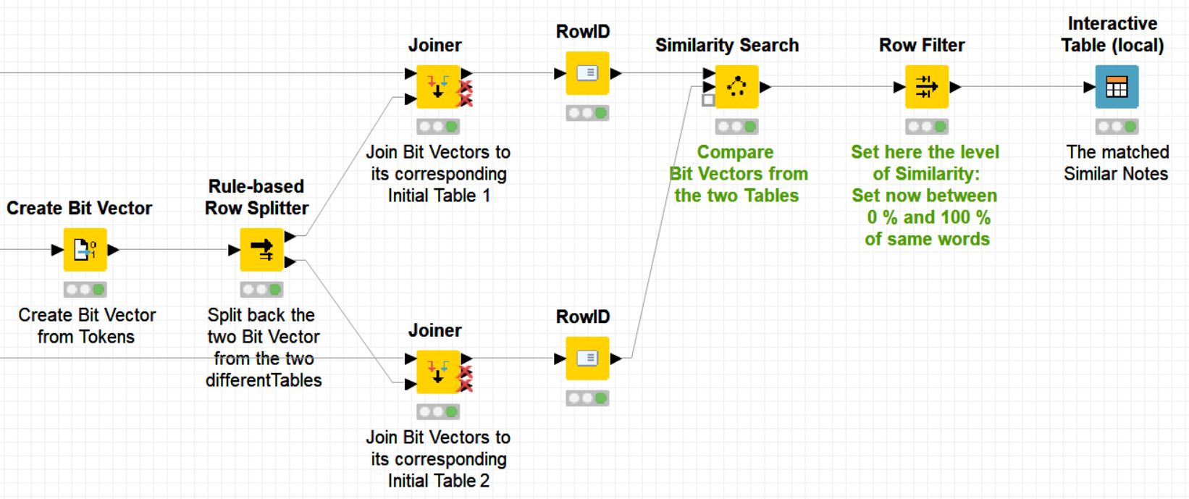

Calculation of Route Similarity and Subsequent Hierarchical Clustering Knime Workflow.

**2.4 Results and Discussion**

* Several metrics are proposed in Methodology section executed on the transportation data obtained from Antalya Municipality. We have discussed Route Efficiency, Traversal Route Evaluation,Variance-Area Curves for Route Board ing, Bus Stop Analysis, and Clustering of Bus Lines with respect to overlapping bus stops.

**3.Route Efficiency- RE:**

* RE The simplest way to evaluate route efficiency (RE) is to calculate the number of passengers per unit distance (km) travelled.
* RE for a route i is given by: RE = Pactual(i) Di (1) where Pactual(i) be the actual number of passengers for Route i and D(i) is the total travel distance in kilometers for this Route.
* Currently, there is not a single number on literature that is suggested to be the benchmark for this metric.
* Because, such metric depends on multiple factors including the dynamics of the population, geography and resources, we calculated RE for all routes and normalize routes with respect to total travel distance via Linear Regression.

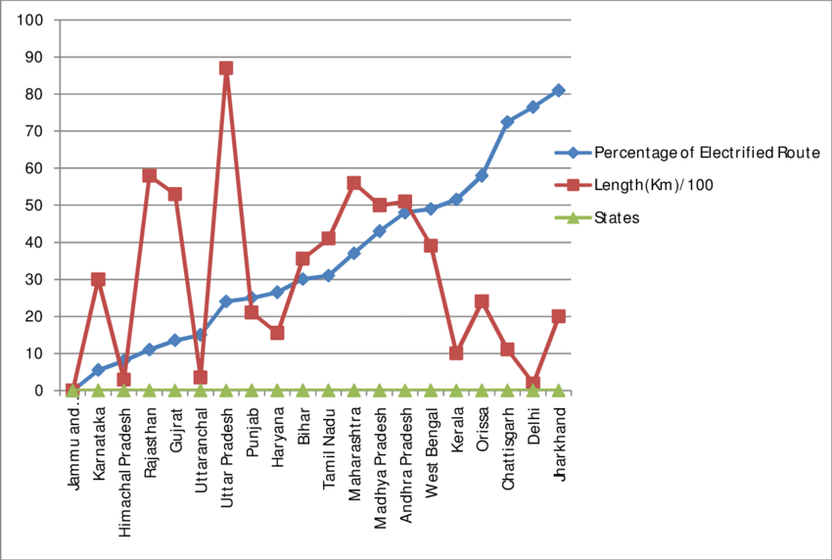

UP C = Pactual(i) + σr

LCL = Pactual(i) – σr

**3.1 Traversal Route :**

* Evaluation When lines are designed they often start from an origin and return back to where it start.
* Each line may have consider to have 2 routes, a forward and backward route.

**3.2 Time-Location Variance Analysis of Route Boarding :**

* Time-Location mapping of route boarding provides us to analyze the variation of boarding in both time domain and as well as route bus stop sequences.
* Mapping involves counting boarding in subsequent bus stops for each trip on a route

**3.3 Bus Stop Analysis:**

* For the selected date, there were 3140 distinct bus stops and among which 2804 has boarding data (at least 1 boarding).
* Among them infrequent bus stops are listed in Table 3. One can conclude from the table that there are 567 ( % 18).

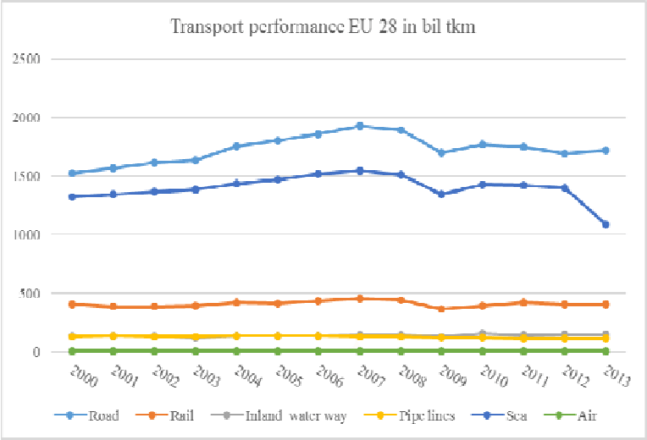

**3.4 Hierarchical Clustering of Routes for Bus Stop Similarity:**

* In Antalya, a major reason for low REs, low bus utilization, high boarding variances on bus stops may be resulted from lengthy bus lines with many overlapping sections.
* This can be investigated by clustering of routes according to their common bus stops.
* The resulted dendrogram presented in Figure 8 shows the hierarchical clustering of bus routes.
* Here x- axis denotes route Ids and y-axis represent similarity distances (y=1 means no similarity whereas y=0 means one hundred percent similarity).

**4. Conclusion :**

* The aim of this study is to identify inefficient routes and to propose improvements by the evaluation of route efficiencies, the analysis of bus stop boarding counts and the clustering of routes.
* Several metrics are proposed in Methodology section executed on the transportation data obtained from Antalya Municipality.

**INNOVATION OBJECTIVES:**

**1. Real-time Data Analytics for Transit Performance Enhancement:**

**- Harness real-time data analytics to make agile adjustments, optimizing routes and ensuring efficient vehicle maintenance for superior transit performance.**

**2. AI-Driven Predictive Maintenance with Data Analytics:**

**- Implement advanced machine learning and data analytics for proactive maintenance, minimizing breakdowns and disruptions through predictive insights.**

**3. Passenger Behavior Insights through Data Analytics:**

**- Utilize sophisticated data analytics to understand intricate ridership patterns, optimizing schedules and routes based on data-driven passenger behavior insights.**

**4. Dynamic Fare and Pricing Strategies with Data Analytics:**

**- Apply cutting-edge data analytics to scrutinize fare structures and pricing models, optimizing revenue with dynamic pricing based on demand and seasonality.**

**5. Integrated Multi-Modal Travel with Data Analytics:**

**- Employ comprehensive data analytics for seamless integration across transportation modes, enhancing overall connectivity and efficiency for passengers.**

**6. Efficient Traffic Flow Modelling using Data Analytics:**

**- Leverage advanced data analytics to optimize signals and road layouts, reducing congestion and boosting public transportation efficiency.**

**7. Green Transportation Evaluation with Data Analytics:**

**- Apply sophisticated data analytics to assess energy consumption and explore eco-friendly alternatives like electric buses, ensuring sustainability.**

**8. Community-Driven Solutions with Data Analytics:**

**- Utilize data analytics to engage the community in data collection and improvement suggestions, identifying and addressing daily passenger issues.**

**9. Digital Transactions and Contactless Payments with Data Analytics:**

**- Implement data analytics in digital ticketing and contactless payments, extracting valuable insights from transaction data for informed decision-making.**

**10. Traffic Signal Priority Systems with Data Analytics:**

**- Employ data analytics for the integration of Traffic Signal Priority (TSP), evaluating its impact on travel times and on-time performance.**

**11. Autonomous Vehicles and MaaS Integration with Data Analytics:**

**- Explore the integration of autonomous vehicles and Mobility as a Service (MaaS) platforms using data analytics for enhanced multi-modal planning.**

**12. Advanced Dynamic Route Optimization with Data Analytics:**

**- Develop and implement dynamic route optimization algorithms with the power of data analytics, considering real-time traffic, weather, and passenger demand for efficiency.**

**13. Sustainable Transportation Practices through Data Analytics:**

**- Apply data analytics to analyze the environmental impact of public transport, implementing strategies for emission reduction and sustainable practices.**

**14. Passenger Satisfaction Surveys with Data Analytics:**

**- Conduct sophisticated data analytics-driven surveys to gather detailed feedback, extracting insights for targeted service quality improvements.**

**15. Smart Infrastructure and IoT Monitoring with Data Analytics:**

**- Utilize data analytics alongside IoT sensors and smart infrastructure for real-time monitoring, extracting actionable insights for enhanced efficiency, safety, and sustainability.**

**16. GIS-Optimized Location Planning with Data Analytics:**

**- Apply data analytics through GIS and spatial analysis to optimize bus stop and station locations, considering population density and urban development.**

**17. Benchmarking Public Transport Efficiency with Data Analytics:**

**- Utilize robust data analytics for benchmarking public transport efficiency against other cities, extracting insights to identify best practices and areas for improvement.**

**18. Strategic Collaboration with Ride-Sharing with Data Analytics:**

**- Implement data analytics in strategic collaborations with ride-sharing companies, analyzing shared ride data for cost-effective and seamless integration.**

**CONCLUSION:**

**Thus by implementing these innovative ideas in the upcoming phases we can achieve the public transport efficiency.**

**Phase-3 Development part-1**

**Objectives:**

This project emphasizes the importance of data analysis and visualization to enhance the efficiency, reliability, and sustainability of public transportation services. Key takeaways from this project include:

* Data-Driven Decision Making: The project demonstrates the power of data-driven decision-making in the domain of public transportation. By collecting, processing, and visualizing data, stakeholders can make informed decisions to improve the quality of service.
* Real-Time Monitoring: The inclusion of real-time data analysis allows for on-the-fly adjustments to routes, schedules, and maintenance. This ensures that transportation services can respond dynamically to changing conditions.
* Passenger Insights: Analysis of passenger data, such as boarding and alighting patterns, preferences, and behavior, helps optimize service delivery and improve the overall passenger experience.
* Environmental Impact: The project can also include an analysis of the environmental impact of the transportation system, providing insights into sustainability and opportunities for reducing emissions.
* Multi-Modal Integration: By integrating various modes of transportation and visualizing data from multiple sources, the project can provide passengers with seamless, convenient, and interconnected mobility options.
* Data Visualization: Data visualization plays a crucial role in presenting complex transportation data in an easily understandable and actionable format. Visualizations like maps, charts, and graphs help stakeholders identify trends, bottlenecks, and areas for improvement.
* Efficiency Optimization: The program demonstrates the use of algorithms and analysis to optimize routes, schedules, and infrastructure to minimize inefficiencies and reduce congestion.
* Sustainability and Innovation: The project promotes sustainable transportation and encourages innovation, such as integrating electric or autonomous vehicles into the system.

In summary, the public transportation efficiency analysis project with data visualization using Python empowers transportation authorities, city planners, and policymakers to make evidence-based decisions that lead to more efficient, sustainable, and passenger-friendly public transportation systems. Data analysis and visualization are essential tools in the ongoing effort to enhance urban mobility and reduce the environmental impact of transportation.

**DATASET:**

**Source:** [**https://www.kaggle.com/datasets/rednivrug/unisys?select=20140711.CSV**](https://www.kaggle.com/datasets/rednivrug/unisys?select=20140711.CSV)

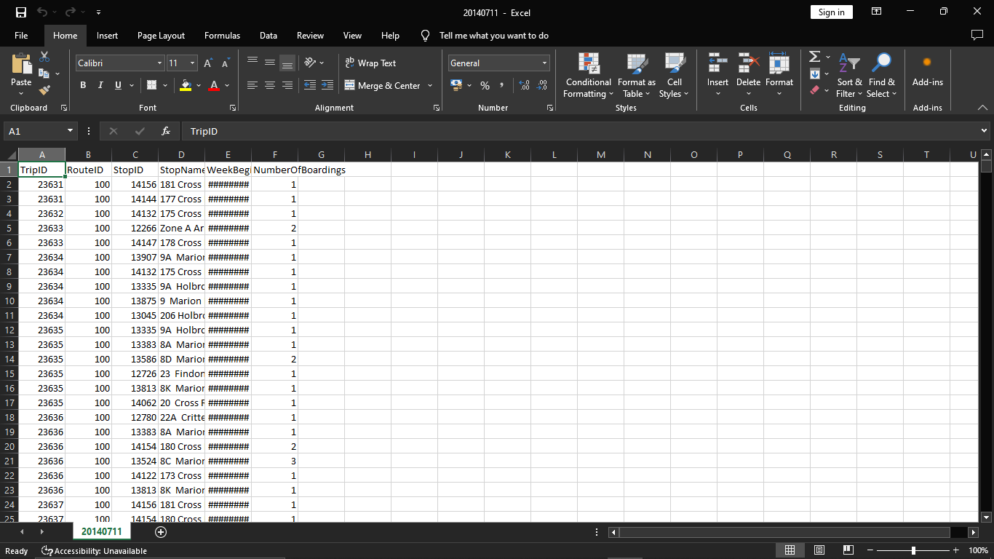

The above dataset has: 1048553 Rows.

**What is data visualization?**

Data visualization is the representation of data in graphical or pictorial format. It involves the use of visual elements like charts, graphs, maps, and other graphical elements to help people understand and interpret data. Data visualization is a powerful tool for conveying complex information, patterns, and insights in a more intuitive and accessible way than raw data or text alone.

The primary goals of data visualization are:

Data Exploration: It allows analysts and data scientists to explore data to identify patterns, trends, anomalies, and relationships within the dataset.

Data Communication: Data visualization makes it easier to communicate data-driven insights to a broader audience, including stakeholders and decision-makers. Visualizations can simplify complex concepts and facilitate understanding.

Data Analysis: Visualizations can assist in the analysis of data, helping to test hypotheses and derive meaningful conclusions.

Decision-Making: Visualizing data can aid in making informed decisions, as it provides a clear and concise way to understand data and its implications.

**Common types of data visualizations include:**

* Bar Charts: Suitable for comparing categories or groups of data.
* Line Charts: Ideal for showing trends and changes over time.
* Pie Charts: Useful for illustrating parts of a whole or proportions.
* Scatter Plots: Display relationships between two variables.
* Heatmaps: Depict data using colour intensity, suitable for matrices and correlations.
* Geospatial Maps: Show data on geographical maps.
* Histograms: Display the distribution of a single variable.
* Box Plots: Show the distribution, central tendency, and outliers of a dataset.
* Sankey Diagrams: Illustrate flow and connections in a system.

Importing libraries in Python is a fundamental step in most programming tasks. Libraries contain pre-written code and functions that you can use to perform various tasks, from data manipulation to machine learning. Here's how you import libraries in Python:

1.Using the import Statement:

The most common way to import libraries is by using the import statement. You simply specify the library/module name after import. You can also use an alias to make it easier to refer to the library in your code.

2.Using Specific Functions/Classes:

You can also import specific functions or classes from a library if you don't need the whole library. This can reduce memory usage and improve code readability.

**Python Program For Data Visualization For Public Transportation Efficiency Analysis:**

**1. Installing pandas:**

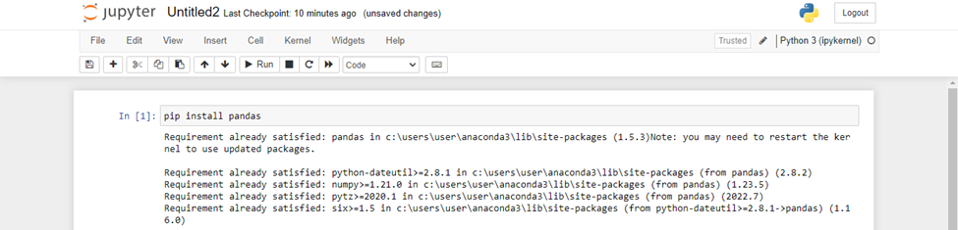

**2. Importing Libraries:**

import pandas as pd

import numpy as np

from sklearn.model_selection import train_test_split

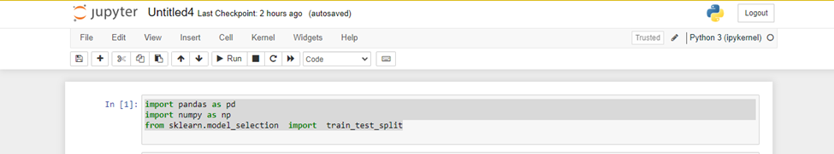

**3. Reading the dataset:**

import pandas as pd

# Replace 'your_file.csv' with the actual path to your CSV file.

file_path = 'C:/Project_dataset.csv'

# Read the CSV file using pandas

try:

df = pd.read_csv(file_path)

# Display the first few rows of the dataframe

print("First few rows of the CSV file:")

print(df.head())

except FileNotFoundError:

print(f"File not found at {file_path}. Please provide a valid file path.")

except Exception as e:

print(f"An error occurred: {e}")

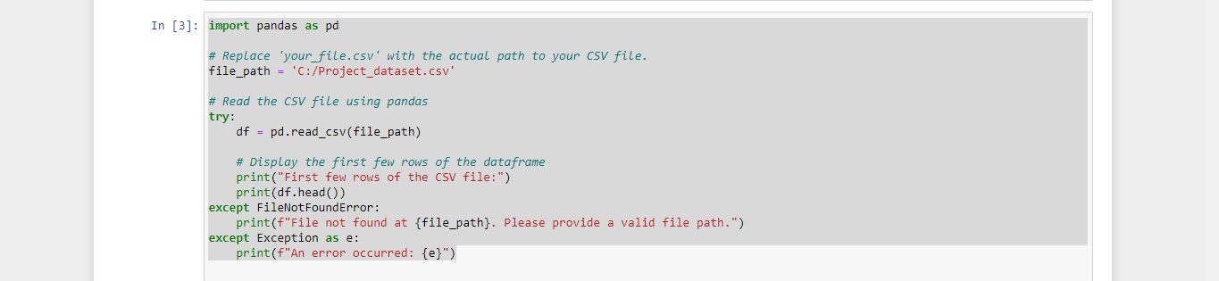

**Output:**

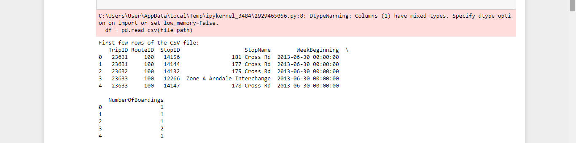

**4. Loading the dataset:**

import pandas as pd

import numpy as np

import seaborn as sns

import matplotlib.pyplot as plt

from sklearn.model_selection import train_test_split

from sklearn.preprocessing import StandardScaler

from sklearn.metrics import r2_score

from sklearn.linear_model import LinearRegression

from sklearn.linear_model import Lasso

from sklearn.ensemble import RandomForestRegressor

from sklearn.svm import SVR

%matplotlib inline

import warnings

warnings.filterwarnings("ignore")

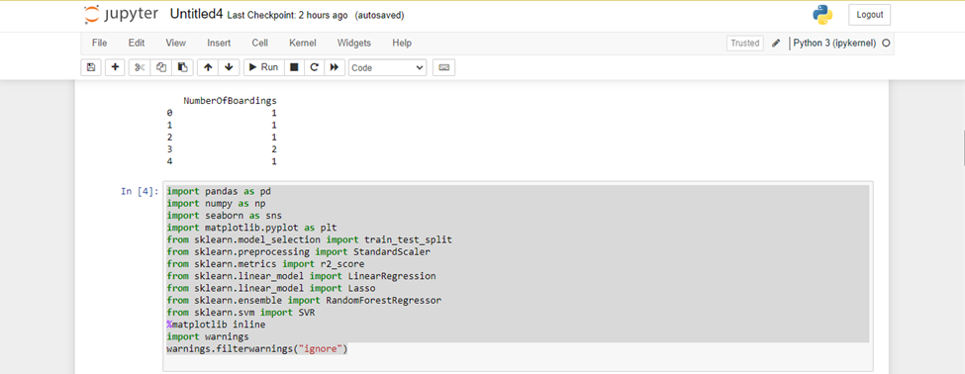

**5. Bar chart:**

sns.histplot(df, x='TripID', bins=50, color='y')

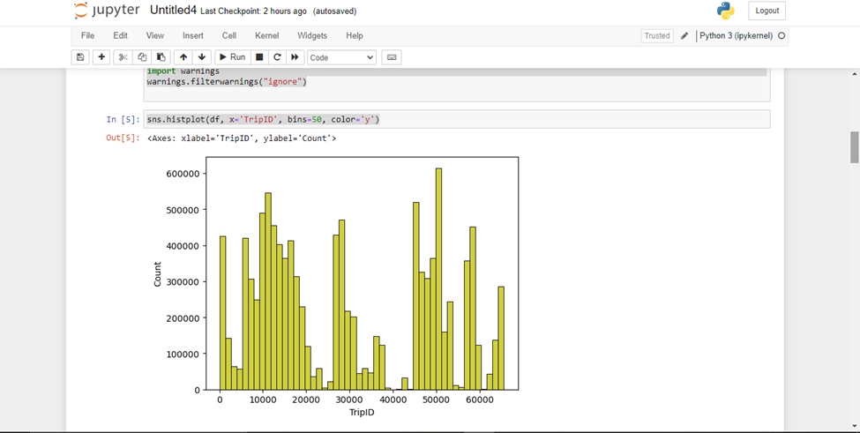

**6. Boxplot:**

sns.boxplot(df, x='TripID', palette='Blues')

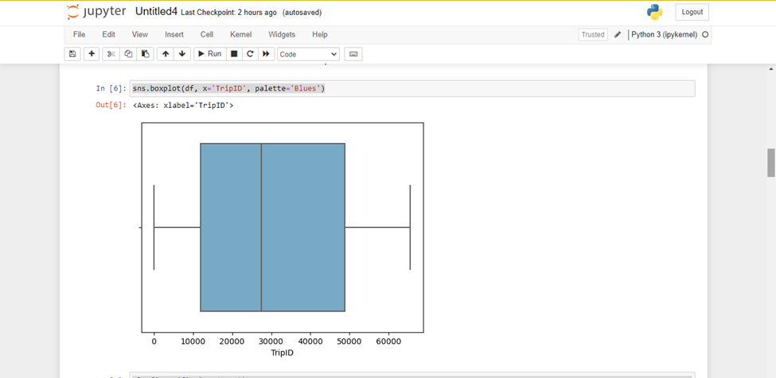

**7. Heatmap:**

plt.figure(figsize=(10,5))

sns.heatmap(df.corr(numeric_only=True),annot=True)

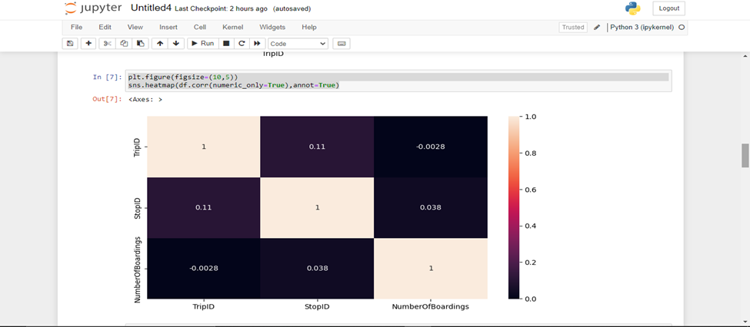

**8. Correlation:**

df.corr(numeric_only=True)

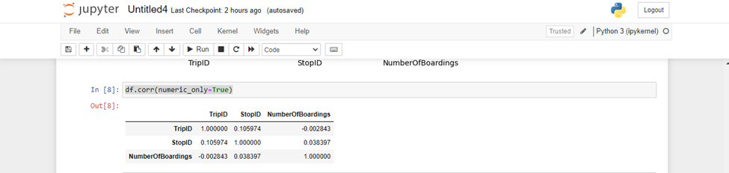

**9. Histogram:**

df.hist(figsize=(10,8))

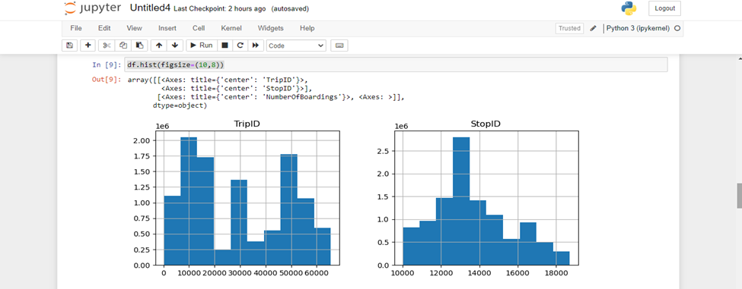

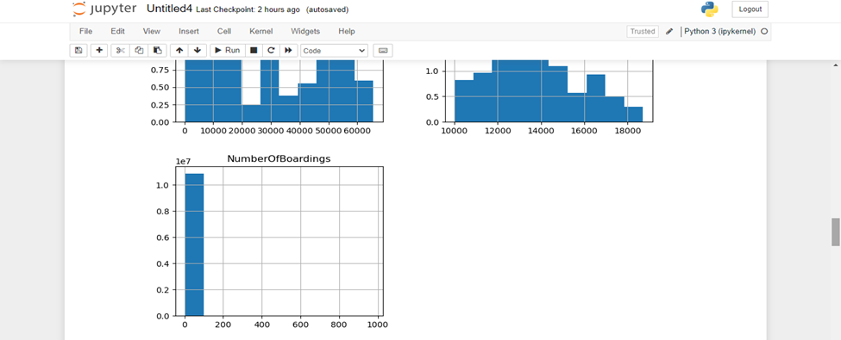

**10. Pair plot:**

plt.figure(figsize=(12,8))

sns.pairplot(df)

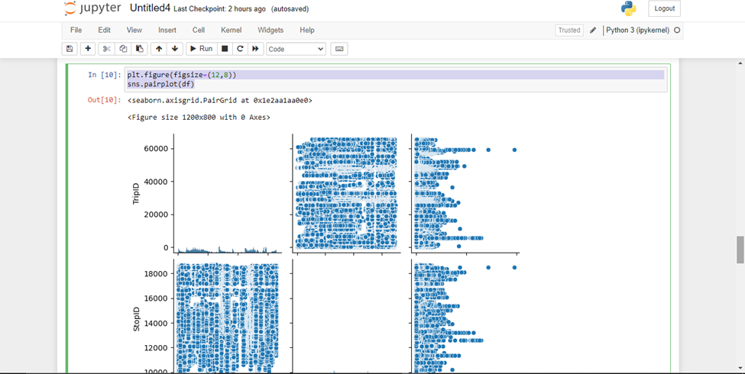

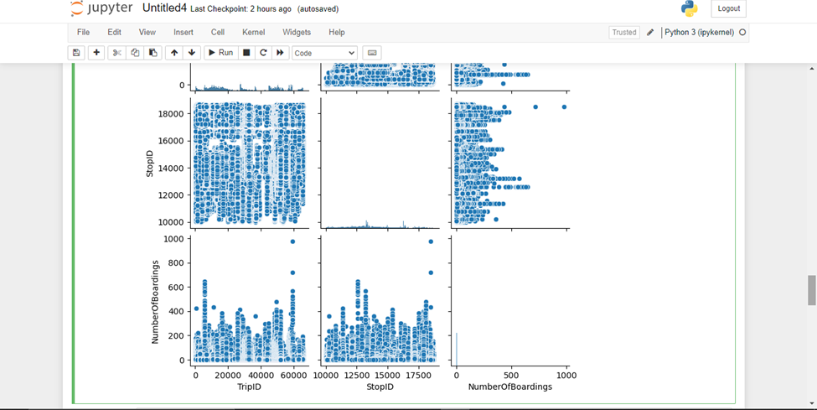

**Conclusion:**

In conclusion, the public transportation efficiency analysis project with data visualization using a Python program serves as a valuable tool for understanding, optimizing, and improving public transportation systems.

**Development part-2**

**Development part-2 using IBM Cognos for Visualization**

**DATASET:**

**Source:**[**https://www.kaggle.com/datasets/rednivrug/unisys?select=20140711.CSV**](https://www.kaggle.com/datasets/rednivrug/unisys?select=20140711.CSV)



The above dataset has: 1048553 Rows.

**Development part-2 using IBM Cognos for visualization**

Building a public transportation efficiency analysis using IBM Cognos for visualization involves several steps. In this process, you'll collect data, prepare it, create data models, and generate visualizations to analyse the efficiency of public transportation services. Here's a step-by-step guide:

**Step 1: Define Your Objectives** Clearly define the objectives of your analysis. Determine what aspects of public transportation efficiency you want to measure and improve, such as on-time performance, ridership, cost-effectiveness, or route optimization.

**Step 2: Data Collection and Integration** Collect relevant data from various sources, including historical transportation records, scheduling information, geographic data, and real-time tracking systems. Ensure that the data is accurate, complete, and up-to-date. IBM Cognos can connect to various data sources, including databases, spreadsheets, and APIs, to import and integrate data.

**Step 3: Data Preparation** Clean, transform, and shape your data to make it suitable for analysis. This involves handling missing data, removing duplicates, and converting data types. IBM Cognos provides data preparation tools to assist with this.

**Step 4: Create Data Models** Design data models that represent the relationships between different data elements. You can use IBM Cognos Framework Manager or the Data Modules feature to create data models that are optimized for performance and user-friendliness.

**Step 5: Report and Dashboard Creation** Now, it's time to build reports and dashboards in IBM Cognos. Here's how:

**a. Create a New Report or Dashboard:** Start by creating a new report or dashboard in IBM Cognos.

**b. Select Data Sources:** Connect your report or dashboard to the data models you've created.

**c. Choose Visualization Types:** Decide on the type of visualizations you want to use. This could include bar charts, line graphs, maps, and tables. IBM Cognos offers a variety of visualization options.

**d. Build Visualizations:** Design and customize your visualizations. For example, you can create a bar chart to display on-time performance by route or a map showing stop locations and their average wait times.

**e. Create Interactivity:** Add interactive elements to your dashboard, such as filters, drill-through capabilities, and parameters that allow users to interact with the data.

**Step 6: Data Analysis and Insights** Use the visualizations in your report or dashboard to analyze the efficiency of public transportation. Identify trends, outliers, and areas for improvement. For example, you can track the most and least efficient routes, analyze peak hours, or evaluate the impact of schedule changes.

**Step 7: Sharing and Collaboration** IBM Cognos allows you to share your reports and dashboards with relevant stakeholders. Collaborate with decision-makers, transportation authorities, and analysts to ensure that the insights are used for making informed decisions.

**Step 8: Schedule and Automation** Set up schedules or triggers for your reports and dashboards to be automatically updated and shared at regular intervals. This ensures that your analysis remains up-to-date.

**Step 9: Monitor and Iterate** Continuously monitor the performance of public transportation and gather user feedback. Use this information to refine your reports and dashboards, making them more insightful and valuable.

By following these steps, you can use IBM Cognos to create an efficient and insightful analysis of public transportation. It helps decision-makers optimize transportation services and improve the overall efficiency of the system.

Top of Form

Bottom of Form

**Trip ID:**

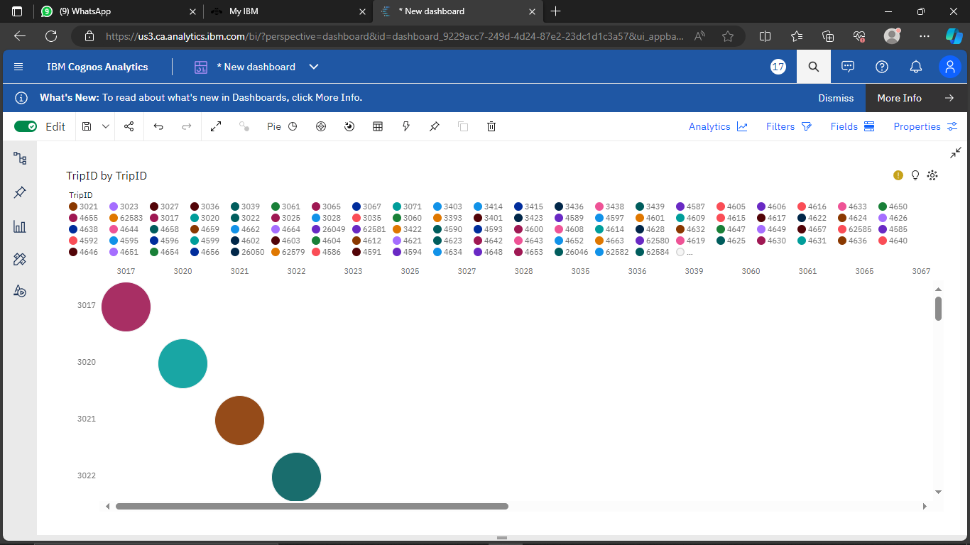

**Stop ID:**

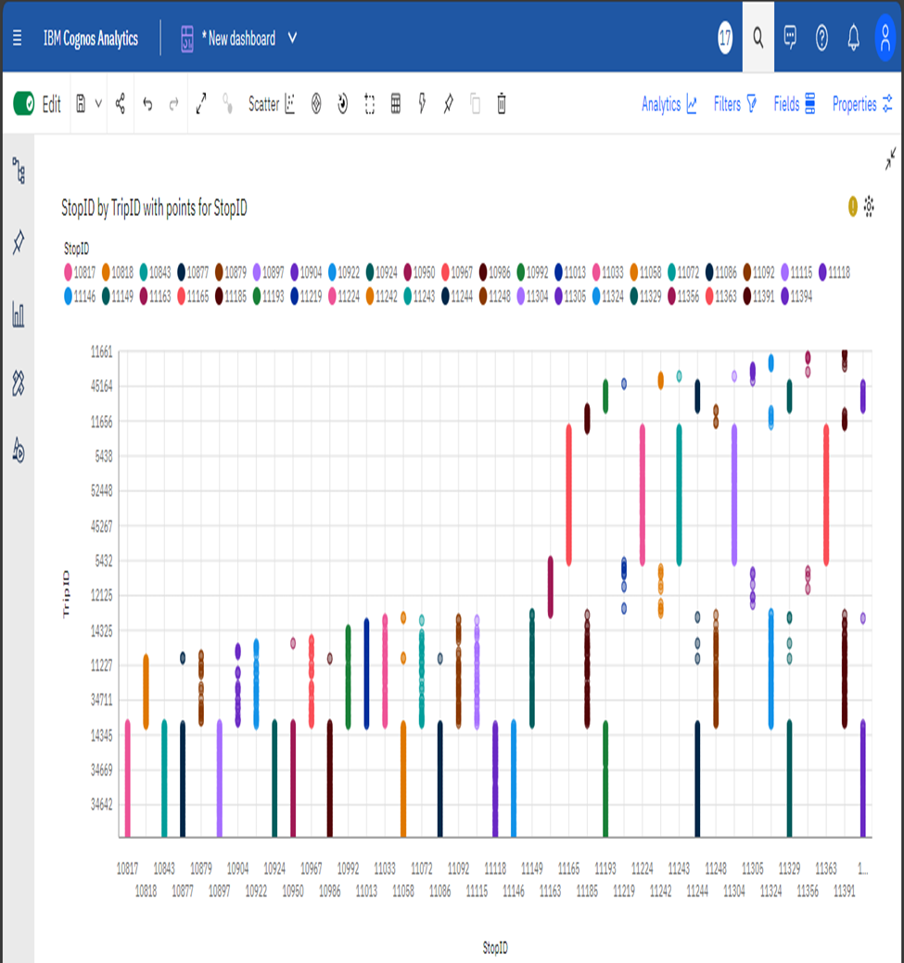

**Number of boardings:**

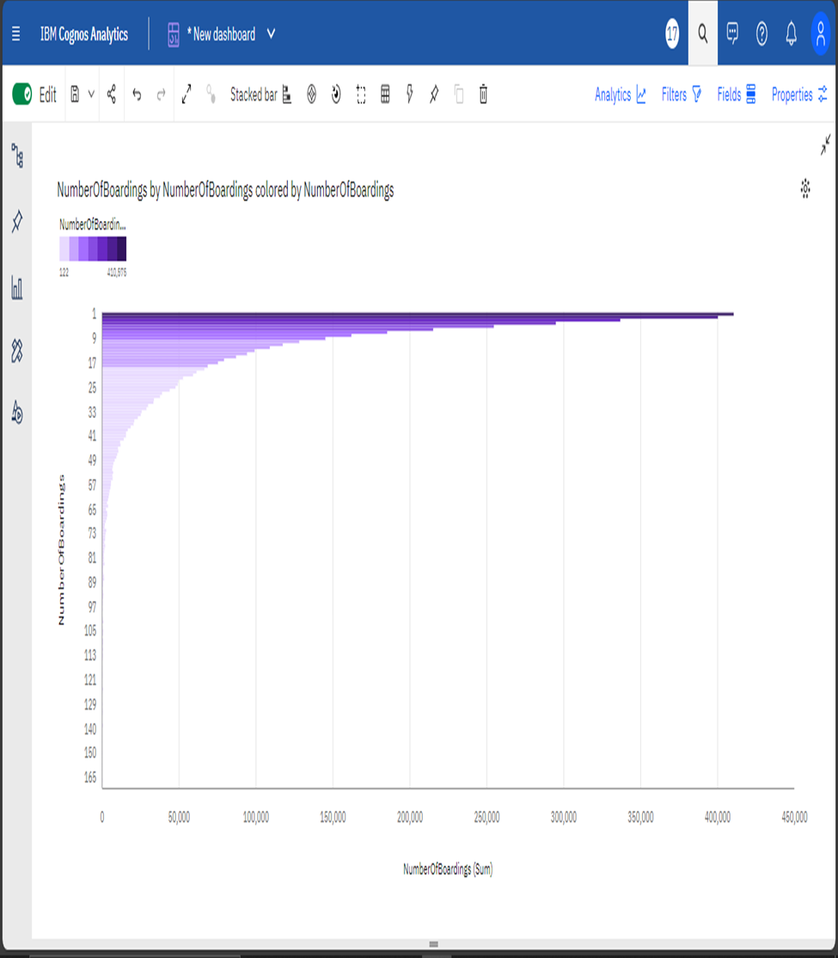

**Route ID:**

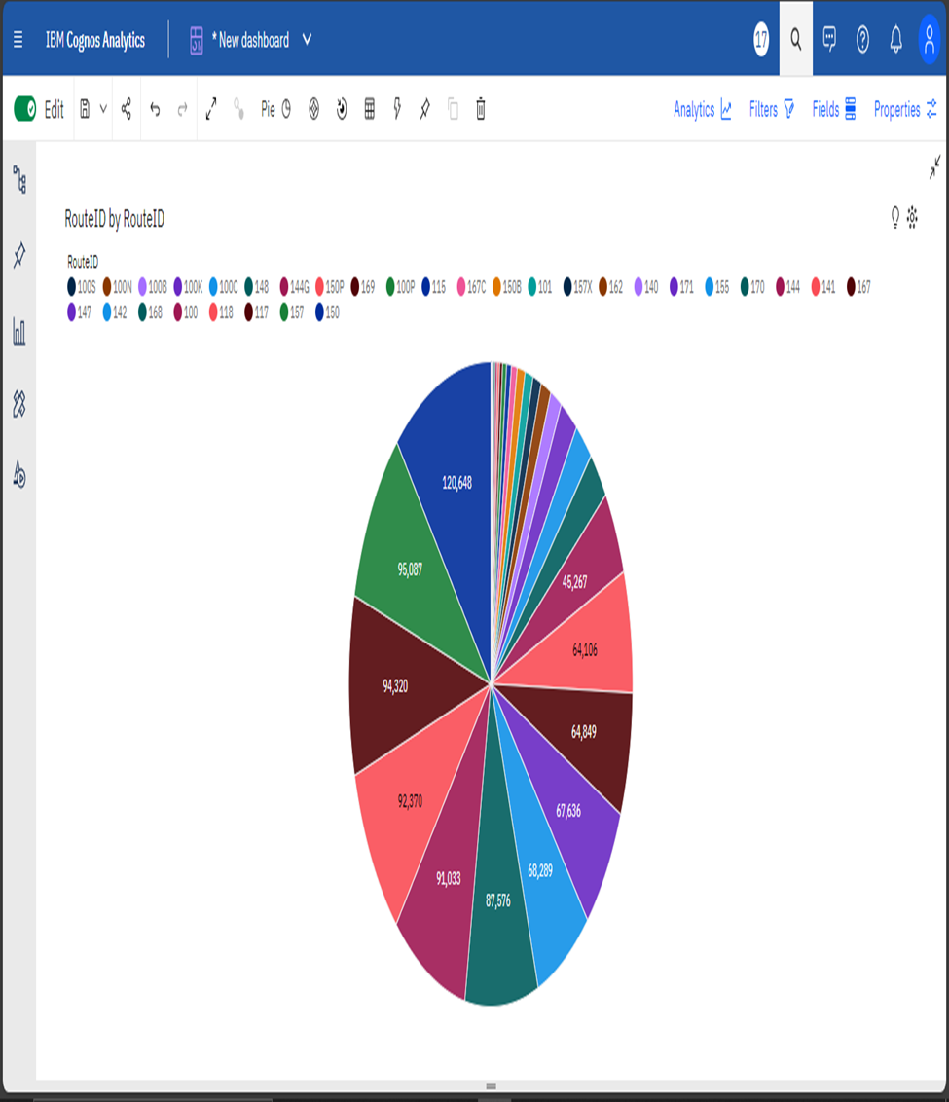

**Week Beginning:**

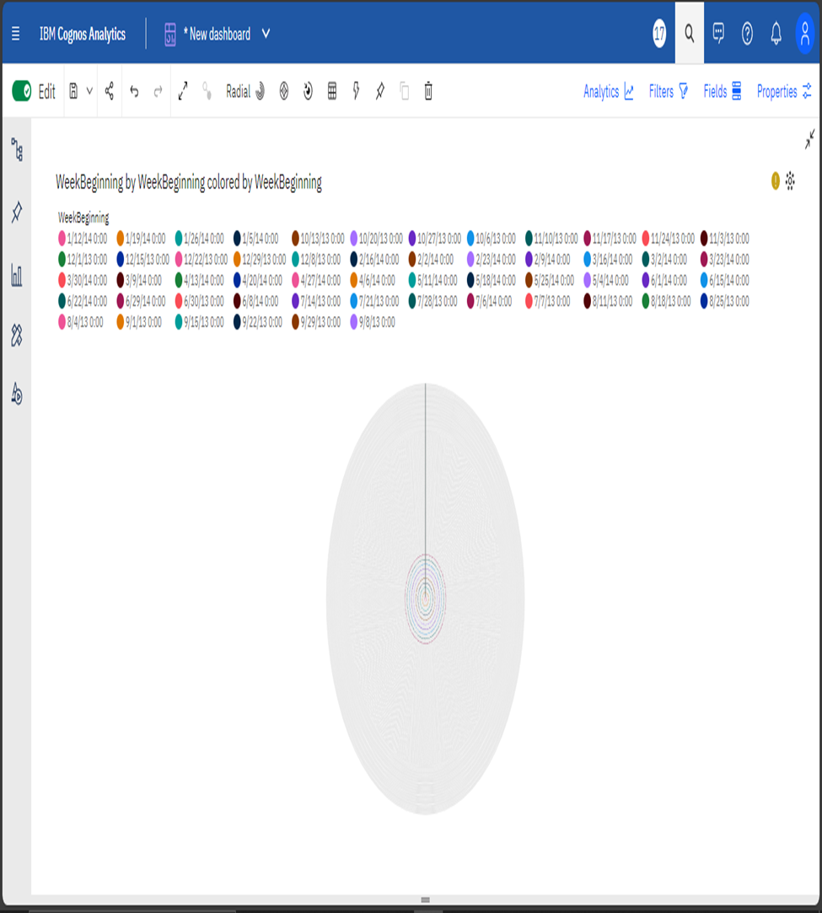

**Stop Names:**

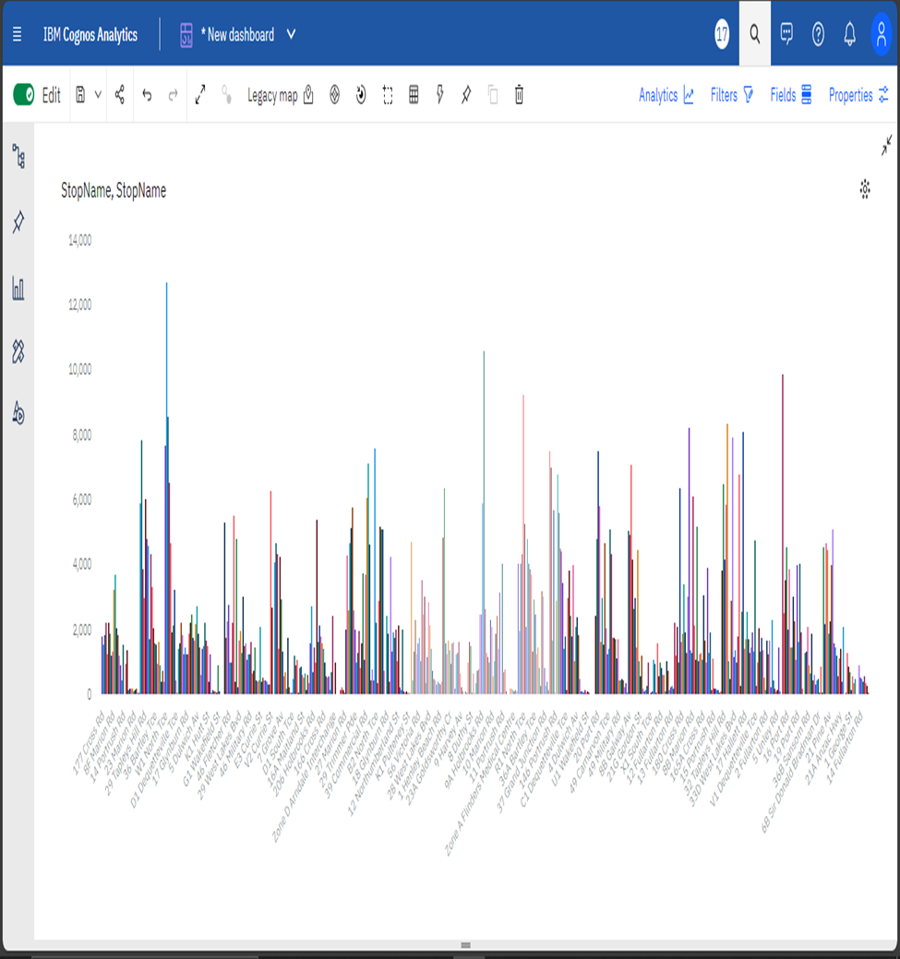

**Python Integration**

**Objective:**

In this notebook, We have explored how people are travelling from different stops in Adelaide Metropolitan area and managing the buses on each route according to the no of passenger commuting through the buses.

**1. Installing pandas:**

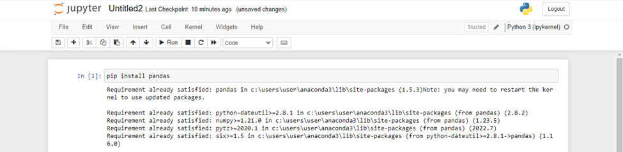

**2. Importing Libraries:**

import pandas as pd

import numpy as np

from sklearn.model_selection import train_test_split

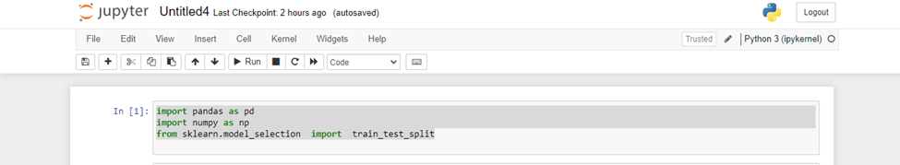

**3. Reading the dataset:**

import pandas as pd

# Replace 'your_file.csv' with the actual path to your CSV file.

file_path = 'C:/Project_dataset.csv'

# Read the CSV file using pandas

try:

df = pd.read_csv(file_path)

# Display the first few rows of the dataframe

print("First few rows of the CSV file:")

print(df.head())

except FileNotFoundError:

print(f"File not found at {file_path}. Please provide a valid file path.")

except Exception as e:

print(f"An error occurred: {e}")



**Output:**



**4. Loading the dataset:**

import pandas as pd

import numpy as np

import seaborn as sns

import matplotlib.pyplot as plt

from sklearn.model_selection import train_test_split

from sklearn.preprocessing import StandardScaler

from sklearn.metrics import r2_score

from sklearn.linear_model import LinearRegression

from sklearn.linear_model import Lasso

from sklearn.ensemble import RandomForestRegressor

from sklearn.svm import SVR

%matplotlib inline

import warnings

warnings.filterwarnings("ignore")



**5. Bar chart:**

sns.histplot(df, x='TripID', bins=50, color='y')



**6. Boxplot:**

sns.boxplot(df, x='TripID', palette='Blues')



**7. Heatmap:**

plt.figure(figsize=(10,5))

sns.heatmap(df.corr(numeric_only=True),annot=True)



**8. Correlation:**

df.corr(numeric_only=True)



**9. Histogram:**

df.hist(figsize=(10,8))





**10. Pair plot:**

plt.figure(figsize=(12,8))

sns.pairplot(df)





**Conclusion:**

In conclusion, the use of IBM Cognos for visualization in the public transportation efficiency analysis project has brought about positive changes, leading to more efficient and user-friendly services, better decision-making, and improved sustainability.